# Introduction

Our analysis provides an overview of the real estate market within Ames Iowa. Our analysis has two sections regarding the association between sales price and livable area within the target market of Century 21 Ames and can be visualized with an R Shiny dashboard at your convenience. The second section discusses the general market of Ames, Iowa, and provides four multiple linear regression models to better understand what factors influence sales prices.

# Data Description

This data set was retrieved from Kaggle[1], features 80 columns and 1460 lines of data in the training set, and an additional 1459 lines in the test set. Descriptions of the variables as well as the fields we used can be accessed via the GitHub link for the project[2].

# Analysis Question 1:

## Restatement of Problem

Century 21 Ames has commissioned a project to better understand the relationship between the sales prices of homes and the livable square footage in their target real estate market of Northern Ames (NAmes), Edwards, and Brookside (BrkSide) neighborhoods.

## Build and Fit the Model

Median{logSalesPrice|logSqFt, Neighborhood} = 8.007 + 0.520*logSqFt + (0.486*NAmes) – (2.094 * BrkSide) – (0.047 * NAmes) + (0.300 * BrkSide)

We have insufficient evidence to conclude there is a significant difference in estimated median price per square foot between Edwards and Northern Ames neighborhoods (p-value = .5203).

Brookside Model:

Median{logSalesPrice|logSqFt, Neighborhood = BrkSide} = 8.007-2.094 + (.520+.300)*logSqFt

Edwards and NAmes Model:

Median{logSalesPrice|logSqFt, Neighborhood = Edwards or NAmes} = 8.007 + 0.520*logSqFt

Checking Assumptions

Residual Plots

*Figure 1 – Original Data Figure 2 – Log transformed Data*

Prior to the log transformation, we see a strong cluster, with outliers. After transforming the data, we still see a strong cluster, but the residuals visually appear to be more normally distributed. The cluster can be explained by the histogram of the residual points which shows most observations cluster around the median.

Influential point analysis (Cook’s D and Leverage)

Original Data:

Transformed Data:

Prior to the transformation, we have several points where which have a much higher Cook’s D. These points will have a much higher influence on the plots relative models than even the highest point in the log transformed data. After the transformation, we still have a few high residual – high leverage points, but will proceed with caution in this analysis.

The high leverage points were homes in Edwards Neighborhood which were sold as “partially completed”; therefore, the cost of the purchase is likely below what the expected sales price would be had it been completed. Further analysis and exploration is recommended for homes sold outside of normal conditions.

Normality:

Original Data:

Log Transformed Data:

Prior to the transformation, most of the data is concentrated around the median with some heavy outliers. Following the log transformation, the data more closely approximates a normal distribution. Additionally, the data set is sufficiently large for the Central Limit Theorem to apply to satisfy the assumption for normality.

Linear Trend and Standard Deviations:

Based on the Q-Q plots, the log transformed data has more evenly distributed data with less clustering, and fewer high leveraged outliers. The data also visually appears to have a linear trend.

Independence:

Real estate sales and appraisal prices are based on comparisons of similar properties in the similar geographical area, shared community amenities (parks, schools, shopping malls, etc.), and many in the area may be built by the same builder. We will be mindful that the industry may have underlying independence concerns while proceeding with caution in this analysis.

Analysis of the Model:

ß0: The intercept in this model provides an estimate of for the cost $ 3001.90 or log(8.007) of 0 square feet of livable area at the reference neighborhood (Edwards, as well as NAmes as there is not enough evidence to suggest they do not follow the same model) . This point is extrapolation as there were no recorded sales of undeveloped land with 0 square feet of livable area. Further research would be needed to determine the cost to purchase undeveloped land, and the intercept would not be an appropriate approximation.

ß1: The adjustment to the intercept for the Brookside neighborhood. The intercept for Brookside neighborhood would be $369.81, or an average cost of log(-2.094) less than that of the reference model.

ß2: The slope of the reference model provides the associated change (log(0.520)) in sales price for each incremental a one unit increase to the livable square feet. The increase for 100 square feet would be associated with $168.20 in the reference (Edwards) neighborhood.

ß3: The adjustment to the slope for Brookside neighborhood (log(-0.047)). The increase of 100 square feet in the Brookside neighborhood would be associated with a $160.50 increase to sales price.

## Conclusion

A doubling of Livable Square Feet in Brookside is associated with a 76.5% (2^.82; 95% Confidence Interval: [55.95%, 99.85%]) multiplicative increase in the estimated median Sales Price. A doubling of Livable Square Feet in Northern Ames or Edwards Neighborhoods is associated with a 43.4% (2^0.52; 95% Confidence Interval: [26.7%, 62.3%]) multiplicative increase in the estimated median Sales Price.

# R Shiny: Price v. Living Area Chart

We created an R Shiny Dashboard for your agents to share with their clients to help them better understand the median sale price within a 95% confidence interval for a given total of livable space. This will assist the agents and clients better understand the market value for each of the three neighborhoods.

The app can be accessed via the following link: <https://tkunz.shinyapps.io/House-Price-Predictor/> and the only two inputs needed are the estimated square feet of the livable area and the neighborhood of interest. After inputting these inputs and pressing the button, the model will estimate the median selling price for the given neighborhood and square footage. The estimated point will also be graphed as an orange triangle, to represent the point visually.

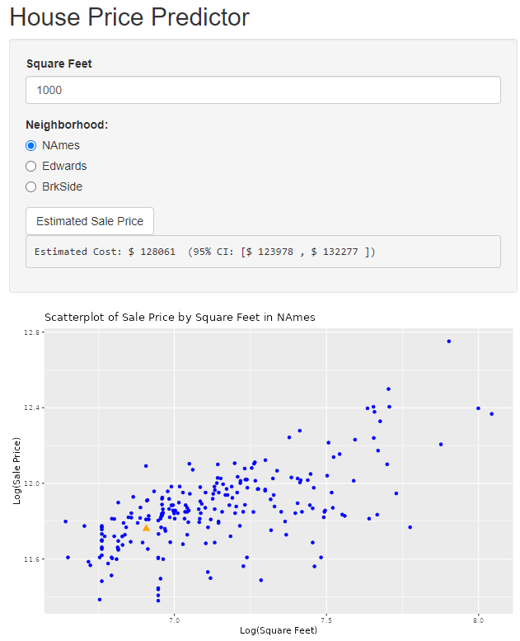

# Analysis Question 2

## Restatement of Problem

The purpose of the second analysis was to create various prediction models to estimate Sales Prices for homes in Ames, Iowa. Specifically, we determined the best single predictor, as well as various other multi-linear regression models (MLRs) to best predict Sales Prices.

## Candidate Models:

Before creating any of the models, it was decided that a healthy approach to the large dataset would begin with wrangling the provided data. After an initial analysis of the data, the following major characteristics were observed:

* “Normal” Sale Conditions accounted for 1,198 of 1,460 records (82.1%) in the training set, and 1,204 of 1,459 records (82.5%) in the test set,
* Many columns (E.g., “ExterQual”) represented categorical data that could be readily converted to numerical data according to a predetermined scale (1 = Excellent, 5 = Poor),
* One column, “CentralAir”, contained Boolean data that could be readily converted to numerical 0/1 data.

Based on these observations, this exercise primarily focused on the homes being sold under “Normal” Sale Conditions, following the domain assumption that abnormal sales could negatively affect the performance of any models due to outlying conditions. Additionally, each of the columns with readily convertible data were converted to numerical data for usage by the model.

### SLR

$$log⁡(SalePrice)=β_{0}+ β_{1}OverallQual$$

Using a Forward and Backward Stepwise Regression (FBSR), the single greatest predictor (Adj. R2 = 0.63) of Sale Price was determined to be the “Overall Qual[ity]” of the property. This fact was consistent with initial expectations. However, the fact that this column only contained ten levels did present an opportunity for an overly broad approach. This concern was addressed and accepted as the team understood MLR models would help establish a more narrow fit for the data.

### MLR 1

$$log⁡(SalePrice)=β_{0}+β_{1}GrLivArea+β_{2}FullBath$$

For the primary MLR model, the Above-Ground Living Area and Full Bathroom count were selected due to their strength as generally assumed predictors.

### MLR 2

$$(Too long to display, see "Appendix-MLR2")$$

The second MLR model was chosen with minimal researcher bias, and was instead determined by selecting for the highest Adjusted R2 score after a FBSR on all predictors, allowing for binary interactions. This model produced an excessive number of parameters; however, as demonstrated further in the comparison section, performed the best on both the training and testing datasets.

### MLR 3

$$log⁡(SalePrice)=β_{0}+β_{1}OverallQual+β_{2}GrLivArea+β_{3}(OverallQual*GrLivArea)+β_{4}(OverallQual*BsmtFinSF1)+β_{5}(GrLivArea*BsmtFinSF1)+β_{6}(OverallQual*TotalBsmtSF)+β_{7}(GrLivArea*TotalBsmtSF)+β_{8}YearRemodAdd+β_{9}(GrLivArea*YearRemodAdd)$$

Finally, after assessing the performance of MLR-2, a more parsimonious model was generated by a FBSR on the five strongest individual predictor, allowing for binary interactions. Although this model produced a promising Adjusted R2 score, it still did not perform as well as MLR-2.

## Checking Assumptions

### Residual Plots

(See Appendix Residual Plots)

Although the right tail of the distribution begins to follow a more exponential trend, the vast majority of the data falls neatly within a linear model.

### Influential point analysis (Cook’s D and Leverage)

(See Appendix Cook’s D and Leverage)

Before adjusting the data, there were a few data points that had high leverage and were strong outliers. These were removed in effort to reduce both the CV PRESS and Adjusted R2 scores in addition to the log transformation performed in AQ1, however, this resulted in little effect on model performance.

## Comparing Competing Models

|  |  |  |  |  |
| --- | --- | --- | --- | --- |
| Predictive Models | Adjusted R2 | CV PRESS | Kaggle Score |  |
| Simple Linear Regression | 0.6518 | 55.25 | 0.47774 |  |
| MLR-1 | 0.5508 | 71.75 | 0.28490 |  |
| MLR-2 | 0.9051 | 11.34 | 0.13348 |  |
| MLR-3 | 0.8876 | 6.36e11 | 0.17277 |  |

## Conclusion: A short summary of the analysis.

Based on the above results, the best model for predictive analysis used 38 interaction parameters. This model had the best results on all three observed metrics, despite lacking any  
parsimony. Despite this model performing the best on training and set data, this team would recommend the third model which controlled for number of parameters, as this model is both easier to explain, and less likely to be an over-fit for the existing data.

# Appendix

## GitHub:

<https://dhlaurel.github.io/ames.pdf>

https://tskunz.github.io/

## Analysis 1 SAS Code:

/* Import training data */

proc import out = work.train

datafile= "/home/u63538552/sasuser.v94/train.csv"

dbms = csv replace;

getnames=yes;

datarow=2;

run;

/* Create a new data set to filter to the 3 Neighborhoods of interest "NAmes", "Edwards", or "BrkSide".

Perform log transformation of the sale price and living area. */

data house;

set work.train;

where Neighborhood in ("NAmes", "Edwards", "BrkSide"); /* Filter observations based on neighborhoods of interest */

logSalePrice = log(SalePrice);

logGrLivArea = log(GrLivArea);

run;

/* Create a scatterplot of SalePrice against GrLivArea */

proc sgplot data=house;

title 'Scatterplot of SalePrice and GrLivArea';

scatter x=GrLivArea y=SalePrice;

xaxis label='GrLivArea';

yaxis label='SalePrice';

run;

/* Create a scatterplot of logSalePrice against logGrLivArea */

proc sgplot data=house;

title 'Scatterplot of LogSalePrice and logGrLivArea';

scatter x=logGrLivArea y=logSalePrice;

xaxis label='logGrLivArea';

yaxis label='logSalePrice';

run;

/* Use proc glm to generate linear regression analysis data for the untransformed data using a common slope.*/

proc glm data=house plots=all;

class Neighborhood;

model SalePrice = GrLivArea Neighborhood / solution;

run;

/* Use proc glm to generate linear regression analysis data for the untransformed data with unique slopes.*/

proc glm data=house plots=all;

class Neighborhood;

model SalePrice = GrLivArea*Neighborhood / solution;

run;

/* Use proc glm to generate linear regression analysis data for the transformed data with equal slopes.*/

proc glm data=house plots=all;

class Neighborhood; /* Specifies Neighborhood as a categorical variable */

model logSalePrice = logGrLivArea Neighborhood / solution; /* Specifies the model */

run;

/* Use proc glm to generate linear regression analysis data for the transformed data with unique slopes.*/

proc glm data=house plots=all;

class Neighborhood; /* Specifies Neighborhood as a categorical variable */

model logSalePrice = logGrLivArea*Neighborhood / solution; /* Specifies the model with interaction */

run;

## RShiny App Code:

### UI:

# ui.R

#load libraries

library(shiny)

library(ggplot2)

#set up the ui for the app

ui = fluidPage(

titlePanel("House Price Predictor"), #app title

sidebarLayout( #set up the side bar

sidebarPanel(

numericInput("sqft", "Square Feet", value = 0), # free numeric input box

radioButtons("neighborhood", "Neighborhood:", #radio button to toggle between neighborhoods

choices = c("NAmes", "Edwards", "BrkSide"),

selected = "NAmes"), # Initial selected value

actionButton("predict_button", "Estimated Sale Price"), # button to run the code to display the output

verbatimTextOutput("prediction_output") # output the results from the server code

),

mainPanel(

plotOutput("regression_plot") #plot the scatterplot from the server code

)

)

)

### Server:

# Load in libraries

library(shiny)

library(tidyverse)

# Load in data set

house = read.csv("https://raw.githubusercontent.com/tskunz/MSDS6371_House_Regression_Project/main/house-prices-advanced-regression-techniques/train.csv")

# filter data and log transform

C21Ames = house %>% filter(Neighborhood %in% c("NAmes", "Edwards", "BrkSide"))

C21Ames$logPrice = log(C21Ames$SalePrice)

C21Ames$logSqFt = log(C21Ames$GrLivArea)

# Different Slope Model with log transformation

fitDifferentSlope = lm(logPrice ~ logSqFt * Neighborhood, data = C21Ames)

# Connect to RShiny

shinyServer(function(input, output) {

# Reactive expression for the Scatter plot

output$regression_plot = renderPlot({

filtered = C21Ames %>% filter(Neighborhood == input$neighborhood) # Using the original log model

predicted_data = data.frame(logSqFt = log(input$sqft), logPrice = predict(fitDifferentSlope, newdata = data.frame(logSqFt = log(input$sqft), Neighborhood = input$neighborhood)), Neighborhood = "Predicted") #Create a separate data frame with the inputs from the app form to allow plotting a separate point for the estimated price

ggplot() +

geom_point(data = filtered, aes(x = logSqFt, y = logPrice, color = Neighborhood)) + # Scatter plot of the log transformed data

geom_point(data = predicted_data, aes(x = logSqFt, y = logPrice), color = "orange", size = 3, shape = 17) + #plot the estimated point

ggtitle(paste("Scatterplot of Sale Price by Square Feet in", input$neighborhood)) + #dynamic title to reflect which neighborhood we are observing

xlab("Log(Square Feet)") + # name of the x axis

ylab("Log(Sale Price)") + # name y axis

scale_color_manual(values = c("NAmes" = "blue", "Edwards" = "blue", "BrkSide" = "blue", "Predicted" = "orange")) + # color the values

theme(legend.position = "none") # Remove the legend

})

# Reactive expression for the prediction using the user inputs from the form

output$prediction_output = renderText({

req(input$predict_button)

new_data = data.frame(

logSqFt = log(input$sqft), # convert the user input into log data to allow to combine into the dynamic graph

Neighborhood = input$neighborhood # pull the response from the neighborhood

)

prediction = round(exp(predict(fitDifferentSlope, newdata = new_data, interval = "confidence")[1])) # Extracting the point estimate and converting out of a log number for interpretability

lower_bound = round(exp(predict(fitDifferentSlope, newdata = new_data, interval = "confidence")[2])) # Extracting the lower bound of the interval and converting out of a log number for interpretability

upper_bound = round(exp(predict(fitDifferentSlope, newdata = new_data, interval = "confidence")[3])) # Extracting the upper bound of the interval and converting out of a log number for interpretability

paste("Estimated Cost: $", prediction, " (95% CI: [$", lower_bound, ", $", upper_bound,"])") # display the estimated sales price for the provided square feet and neighborhood

})

})

## Analysis 2 R Code:

### PROJECT ###

# Setup

#ames_data = read.csv(file.choose())

#ames_test_kaggle = read.csv(file.choose())

head(ames_data)

# Wrangling

## Check for normal only

library(dplyr)

ames_normal = ames_data[ames_data$SaleCondition == 'Normal',]

ames_adj = ames_data

ames_adj = ames_adj %>% select(-SaleCondition)

ames_adj[ames_adj == 'Ex'] = 1

ames_adj[ames_adj == 'Gd'] = 2

ames_adj[ames_adj == 'TA'] = 3

ames_adj[ames_adj == 'Fa'] = 4

ames_adj[ames_adj == 'Po'] = 5

ames_adj$CentralAir = ifelse(ames_adj$CentralAir == 'Y', 1, 0)

ames_adj$PavedDrive = ifelse(ames_adj$PavedDrive == 'Y', 1, 0)

ames_adj$LotShape = ifelse(ames_adj$LotShape == 'Reg', 1, 0)

ames_adj$Street = ifelse(ames_adj$Street == 'Pave', 1, 0)

ames_adj$LandContour = ifelse(ames_adj$LandContour == 'Lvl', 1, 0)

ames_adj$Exterior1st = ifelse(ames_adj$Exterior1st == 'AsbShng', 1, 0)

ames_adj$Exterior2nd = ifelse(ames_adj$Exterior2nd == 'AsbShng', 1, 0)

ames_adj$Functional = ifelse(ames_adj$Functional == 'Sev' | ames_adj$Functional == 'Sal', 1, 0)

ames_adj$ExterCond = as.numeric(ames_adj$ExterCond)

ames_adj$ExterQual = as.numeric(ames_adj$ExterQual)

ames_adj$HeatingQC = as.numeric(ames_adj$HeatingQC)

ames_adj$CentralAir = as.numeric(ames_adj$CentralAir)

ames_adj$KitchenQual = as.numeric(ames_adj$KitchenQual)

ames_adj$PavedDrive = as.numeric(ames_adj$PavedDrive)

ames_adj$LotShape = as.numeric(ames_adj$LotShape)

ames_adj$Street = as.numeric(ames_adj$Street)

ames_adj$LandContour = as.numeric(ames_adj$LandContour)

ames_adj$Exterior1st = as.numeric(ames_adj$Exterior1st)

ames_adj$Exterior2nd = as.numeric(ames_adj$Exterior2nd)

ames_adj$Functional = as.numeric(ames_adj$Functional)

ames_adj$LotFrontage[is.na(ames_adj$LotFrontage)] = mean(ames_adj$LotFrontage, na.rm=TRUE)

ames_adj$MasVnrArea[is.na(ames_adj$MasVnrArea)] = mean(ames_adj$MasVnrArea, na.rm=TRUE)

ames_adj$GarageYrBlt [is.na(ames_adj$GarageYrBlt )] = mean(ames_adj$GarageYrBlt , na.rm=TRUE)

ames_adj$LotFrontage[is.na(ames_adj$LotFrontage)] = mean(ames_adj$LotFrontage, na.rm=TRUE)

ames_adj$LotFrontage[is.na(ames_adj$LotFrontage)] = mean(ames_adj$LotFrontage, na.rm=TRUE)

ames_adj$LotFrontage[is.na(ames_adj$LotFrontage)] = mean(ames_adj$LotFrontage, na.rm=TRUE)

ames_adj$LotFrontage[is.na(ames_adj$LotFrontage)] = mean(ames_adj$LotFrontage, na.rm=TRUE)

ames_adj$LogSalePrice = log(ames_adj$SalePrice)

factor_i = sapply(ames_adj, is.factor)

numeric_i = sapply(ames_adj, is.numeric)

## For Normal sales, only one Functional category

ames_adj = ames_adj %>% select(-c(Functional, ))

## Export to csv for SAS

write.csv(ames_adj, file.choose(), row.names=FALSE)

ames_log = ames_log %>% select(-c(Functional, ))

which(numeric_i)

ames_data_numeric = ames_adj[, numeric_i]

## Count unique values for each variable:

sapply(lapply(ames_data_numeric, unique), length)

lapply(ames_data_numeric, unique)

## Log transforms

ames_log = ames_data

ames_log$LogSalePrice = log(ames_data$SalePrice)

ames_log$LogOverallQual = log(ames_data$OverallQual)

ames_log = ames_log %>% select(-c(SalePrice, ))

numeric_i = sapply(ames_log, is.numeric)

ames_log_numeric = ames_log[, numeric_i]

#-----------

# Part 1. Best single predictor

fit = lm(LogSalePrice ~ OverallQual, ames_log_numeric)

summary(fit)

fit2 = lm(LogSalePrice ~ GrLivArea, ames_log_numeric)

summary(fit2)

ggplot(ames_data, aes(x=LogOverallQual, y=log(SalePrice))) +

geom_point() +

geom_smooth(method='lm')

ggplot(ames_data, aes(x=OverallQual, y=SalePrice)) +

geom_point() +

geom_smooth(method='lm')

## Check for interactions

fit = lm(LogSalePrice ~., data=ames_log_numeric)

## Stepwise

step_aic = ols_step_both_aic(fit, details=TRUE)

step_adjr = ols_step_both_adj_r2(fit, details=TRUE)

#-----------

# Part 2. MLR with GrLivArea + FullBath

fit = lm(SalePrice ~ GrLivArea + FullBath, ames_sorted)

summary(fit)

# Split data into train and test

set.seed(1)

sample = sample(c(TRUE, FALSE), nrow(ames_sorted), replace=TRUE, prob=c(0.7, 0.3))

ames_train = ames_sorted[sample, ]

ames_test = ames_sorted[!sample, ]

# Fit model to training data

fit = lm(SalePrice ~ GrLivArea + FullBath, ames_train)

# Generate predictions based on model

predictions = predict(fit, ames_test)

# Compare predicted value to actual

ames_compare = data.frame(Predicted=predictions, Actual=ames_test$SalePrice)

ames_compare$ID = 1:nrow(ames_compare)

ames_compare$Diff = ames_compare$Predicted - ames_compare$Actual

# Plot the differences

ames_plot = data.frame(x=rep(1:nrow(ames_compare), 2),

value=c(ames_compare$Predicted, ames_compare$Actual),

variable=c(rep('Predicted', nrow(ames_compare)), rep('Actual', nrow(ames_compare)))

)

ggplot(ames_plot, aes(x=x, y=value)) +

geom_line(aes(color=variable))

#-------------

# Part 3. Second attempt in R

library(olsrr)

library(tidyverse)

library(caret)

library(GGally)

head(ames_data)

## Count unique values for each variable:

sapply(lapply(ames_data, unique), length)

#ggpairs(ames_data_numeric)

## Check for interactions

fit = lm(SalePrice ~., data=ames_data_numeric)

## Stepwise

step_aic = ols_step_both_aic(fit, details=TRUE)

step_adjr = ols_step_both_adj_r2(fit, details=TRUE)

## Train Control

train_control<- trainControl(method="LOOCV")

model <- train(SalePrice ~ GrLivArea + FullBath, data=ames_data_numeric, trControl=train_control, method="lm")

model

nrow(ames_data_numeric[complete.cases(ames_data_numeric),])

sapply(ames_data_numeric, function(x)any(is.na(x)))

nrow(na.exclude(ames_data_numeric))

model <- train(SalePrice ~ LotArea*LandContour + LandContour*OverallQual + YearBuilt*YearRemodAdd + LotArea*ExterQual + OverallCond*ExterQual + ExterQual*BsmtFinSF1 + LotShape*BsmtUnfSF + BsmtFinSF2*BsmtUnfSF + OverallQual*TotalBsmtSF + OverallCond*TotalBsmtSF + ExterQual*TotalBsmtSF + BsmtFinSF1*TotalBsmtSF + BsmtUnfSF*TotalBsmtSF + MSSubClass*X2ndFlrSF + MasVnrArea*X2ndFlrSF + TotalBsmtSF*X2ndFlrSF + Street*GrLivArea + OverallQual*GrLivArea + OverallQual*BsmtFullBath + MSSubClass*BedroomAbvGr + BsmtFullBath*BedroomAbvGr + LandContour*KitchenQual + GrLivArea*KitchenQual + BsmtFullBath*TotRmsAbvGrd + LotArea*Fireplaces + OverallCond*Fireplaces + BsmtFullBath*Fireplaces + FullBath*Fireplaces + BedroomAbvGr*Fireplaces + LotArea*GarageCars + Fireplaces*GarageCars + FullBath*GarageArea + CentralAir*PavedDrive + EnclosedPorch*X3SsnPorch + BsmtUnfSF*ScreenPorch + X2ndFlrSF*PoolArea + YearRemodAdd*YrSold + KitchenAbvGr*OverallQual, data=ames_data_numeric,trControl=train_control, method="lm")

model

predictions = predict(model, ames_adj)

summary(predictions)

ames_adj$PredictedSalePrice = predictions

compare_df = data.frame(SalePrice = c(ames_adj$SalePrice, ames_adj$PredictedSalePrice), Variable=c(rep('Actual', nrow(ames_adj)), rep('Predicted', nrow(ames_adj))),ID = rep(rank(ames_adj$SalePrice), 2))

ggplot(compare_df, aes(x=ID, y=SalePrice)) +

geom_point(aes(color=Variable), alpha=0.3)

# Kaggle Submission

## Setup (Copied from ames_adj):

ames_test_kaggle[ames_test_kaggle == 'Ex'] = 1

ames_test_kaggle[ames_test_kaggle == 'Gd'] = 2

ames_test_kaggle[ames_test_kaggle == 'TA'] = 3

ames_test_kaggle[ames_test_kaggle == 'Fa'] = 4

ames_test_kaggle[ames_test_kaggle == 'Po'] = 5

ames_test_kaggle$CentralAir = ifelse(ames_test_kaggle$CentralAir == 'Y', 1, 0)

ames_test_kaggle$PavedDrive = ifelse(ames_test_kaggle$PavedDrive == 'Y', 1, 0)

ames_test_kaggle$LotShape = ifelse(ames_test_kaggle$LotShape == 'Reg', 1, 0)

ames_test_kaggle$Street = ifelse(ames_test_kaggle$Street == 'Pave', 1, 0)

ames_test_kaggle$LandContour = ifelse(ames_test_kaggle$LandContour == 'Lvl', 1, 0)

ames_test_kaggle$Exterior1st = ifelse(ames_test_kaggle$Exterior1st == 'AsbShng', 1, 0)

ames_test_kaggle$Exterior2nd = ifelse(ames_test_kaggle$Exterior2nd == 'AsbShng', 1, 0)

ames_test_kaggle$Functional = ifelse(ames_test_kaggle$Functional == 'Sev' | ames_test_kaggle$Functional == 'Sal', 1, 0)

ames_test_kaggle$ExterCond = as.numeric(ames_test_kaggle$ExterCond)

ames_test_kaggle$ExterQual = as.numeric(ames_test_kaggle$ExterQual)

ames_test_kaggle$HeatingQC = as.numeric(ames_test_kaggle$HeatingQC)

ames_test_kaggle$CentralAir = as.numeric(ames_test_kaggle$CentralAir)

ames_test_kaggle$KitchenQual = as.numeric(ames_test_kaggle$KitchenQual)

ames_test_kaggle$PavedDrive = as.numeric(ames_test_kaggle$PavedDrive)

ames_test_kaggle$LotShape = as.numeric(ames_test_kaggle$LotShape)

ames_test_kaggle$Street = as.numeric(ames_test_kaggle$Street)

ames_test_kaggle$LandContour = as.numeric(ames_test_kaggle$LandContour)

ames_test_kaggle$Exterior1st = as.numeric(ames_test_kaggle$Exterior1st)

ames_test_kaggle$Exterior2nd = as.numeric(ames_test_kaggle$Exterior2nd)

ames_test_kaggle$Functional = as.numeric(ames_test_kaggle$Functional)

ames_test_kaggle$LotFrontage[is.na(ames_test_kaggle$LotFrontage)] = mean(ames_test_kaggle$LotFrontage, na.rm=TRUE)

ames_test_kaggle$MasVnrArea[is.na(ames_test_kaggle$MasVnrArea)] = mean(ames_test_kaggle$MasVnrArea, na.rm=TRUE)

ames_test_kaggle$GarageYrBlt [is.na(ames_test_kaggle$GarageYrBlt )] = mean(ames_test_kaggle$GarageYrBlt , na.rm=TRUE)

ames_test_kaggle$TotalBsmtSF[is.na(ames_test_kaggle$TotalBsmtSF)] = mean(ames_test_kaggle$TotalBsmtSF, na.rm=TRUE)

ames_test_kaggle$GarageArea[is.na(ames_test_kaggle$GarageArea)] = mean(ames_test_kaggle$GarageArea, na.rm=TRUE)

ames_test_kaggle$BsmtUnfSF[is.na(ames_test_kaggle$BsmtUnfSF)] = mean(ames_test_kaggle$BsmtUnfSF, na.rm=TRUE)

ames_test_kaggle$BsmtFullBath[is.na(ames_test_kaggle$BsmtFullBath)] = mean(ames_test_kaggle$BsmtFullBath, na.rm=TRUE)

ames_test_kaggle$BsmtFinSF2[is.na(ames_test_kaggle$BsmtFinSF2)] = mean(ames_test_kaggle$BsmtFinSF2, na.rm=TRUE)

ames_test_kaggle$BsmtFinSF1[is.na(ames_test_kaggle$BsmtFinSF1)] = mean(ames_test_kaggle$BsmtFinSF1, na.rm=TRUE)

ames_test_kaggle$KitchenQual[is.na(ames_test_kaggle$KitchenQual)] = mean(ames_test_kaggle$KitchenQual, na.rm=TRUE)

ames_test_kaggle$GarageCars[is.na(ames_test_kaggle$GarageCars)] = mean(ames_test_kaggle$GarageCars, na.rm=TRUE)

ames_test_kaggle$LotFrontage[is.na(ames_test_kaggle$LotFrontage)] = mean(ames_test_kaggle$LotFrontage, na.rm=TRUE)

ames_test_kaggle$LotFrontage[is.na(ames_test_kaggle$LotFrontage)] = mean(ames_test_kaggle$LotFrontage, na.rm=TRUE)

ames_test_kaggle$LotFrontage[is.na(ames_test_kaggle$LotFrontage)] = mean(ames_test_kaggle$LotFrontage, na.rm=TRUE)

ames_test_kaggle$LotFrontage[is.na(ames_test_kaggle$LotFrontage)] = mean(ames_test_kaggle$LotFrontage, na.rm=TRUE)

ames_test_kaggle$LotFrontage[is.na(ames_test_kaggle$LotFrontage)] = mean(ames_test_kaggle$LotFrontage, na.rm=TRUE)

sapply(ames_test_kaggle, function(x) sum(is.na(x)))

ames_test_kaggle[complete.cases(ames_test_kaggle),]

## 1. SLR

model <- train(SalePrice ~ OverallQual, data=ames_data_numeric, trControl=train_control, method="lm")

model

kaggle_predictions = predict(model, newdata=ames_test_kaggle)

kaggle_predictions

ames_test_kaggle$Predictions = kaggle_predictions

kaggle_submission = data.frame(Id=ames_test_kaggle$Id, SalePrice=ames_test_kaggle$Predictions)

write.csv(kaggle_submission, file.choose(), row.names=FALSE)

## 2. MLR

model <- train(SalePrice ~ GrLivArea + FullBath, data=ames_data_numeric, trControl=train_control, method="lm")

model

kaggle_predictions = predict(model, newdata=ames_test_kaggle)

kaggle_predictions

ames_test_kaggle$Predictions = kaggle_predictions

kaggle_submission = data.frame(Id=ames_test_kaggle$Id, SalePrice=ames_test_kaggle$Predictions)

write.csv(kaggle_submission, file.choose(), row.names=FALSE)

## 3. Custom

model <- train(LogSalePrice ~ LotArea*LandContour + LandContour*OverallQual + YearBuilt*YearRemodAdd + LotArea*ExterQual + OverallCond*ExterQual + ExterQual*BsmtFinSF1 + LotShape*BsmtUnfSF + BsmtFinSF2*BsmtUnfSF + OverallQual*TotalBsmtSF + OverallCond*TotalBsmtSF + ExterQual*TotalBsmtSF + BsmtFinSF1*TotalBsmtSF + BsmtUnfSF*TotalBsmtSF + MSSubClass*X2ndFlrSF + MasVnrArea*X2ndFlrSF + TotalBsmtSF*X2ndFlrSF + Street*GrLivArea + OverallQual*GrLivArea + OverallQual*BsmtFullBath + MSSubClass*BedroomAbvGr + BsmtFullBath*BedroomAbvGr + LandContour*KitchenQual + GrLivArea*KitchenQual + BsmtFullBath*TotRmsAbvGrd + LotArea*Fireplaces + OverallCond*Fireplaces + BsmtFullBath*Fireplaces + FullBath*Fireplaces + BedroomAbvGr*Fireplaces + LotArea*GarageCars + Fireplaces*GarageCars + FullBath*GarageArea + CentralAir*PavedDrive + EnclosedPorch*X3SsnPorch + BsmtUnfSF*ScreenPorch + X2ndFlrSF*PoolArea + YearRemodAdd*YrSold + KitchenAbvGr*OverallQual, data=ames_data_numeric,trControl=train_control, method="lm")

model

kaggle_predictions = predict(model, newdata=ames_test_kaggle)

kaggle_predictions

ames_test_kaggle$Predictions = exp(kaggle_predictions)

kaggle_submission = data.frame(Id=ames_test_kaggle$Id, SalePrice=ames_test_kaggle$Predictions)

write.csv(kaggle_submission, file.choose(), row.names=FALSE)

## 4. Custom 2

model <- train(SalePrice ~ OverallQual + GrLivArea + OverallQual*GrLivArea + OverallQual*BsmtFinSF1 + GrLivArea*BsmtFinSF1 + OverallQual*TotalBsmtSF + GrLivArea*TotalBsmtSF + YearRemodAdd + GrLivArea*YearRemodAdd, data=ames_data_numeric, trControl=train_control, method="lm")

model

kaggle_predictions = predict(model, newdata=ames_test_kaggle)

kaggle_predictions

ames_test_kaggle$Predictions = kaggle_predictions

kaggle_submission = data.frame(Id=ames_test_kaggle$Id, SalePrice=ames_test_kaggle$Predictions)

write.csv(kaggle_submission, file.choose(), row.names=FALSE)

## Analysis 2 SAS Code:

FILENAME REFFILE '/home/u63732424/sasuser.v94/ames_adj.csv';  
  
PROC IMPORT REPLACE DATAFILE=REFFILE DBMS=CSV OUT=ames;  
 GETNAMES=YES;  
run;  
  
DATA ames_abr;  
 SET ames;  
 if _n_ = 564 then delete;  
 if _n_ = 278 then delete;  
 LogSalePrice = log(SalePrice);  
run;  
  
proc glmselect data=ames;  
 model SalePrice=GrLivArea FullBath / selection=Forward(stop=SL SLE=0.5)   
 stats=adjrsq CVDETAILS;  
run;  
  
proc glmselect data=ames;  
 model SalePrice=GrLivArea FullBath / selection=Forward(stop=CV)   
 cvmethod=random(5) stats=adjrsq CVDETAILS;  
run;  
  
proc glmselect data=ames;  
 model SalePrice=MSSubClass LotArea OverallQual OverallCond YearBuilt   
 YearRemodAdd MasVnrArea BsmtFinSF1 BsmtFinSF2 BsmtUnfSF TotalBsmtSF   
 LowQualFinSF GrLivArea BsmtFullBath BsmtHalfBath FullBath HalfBath   
 BedroomAbvGr KitchenAbvGr TotRmsAbvGrd Fireplaces GarageYrBlt GarageCars   
 GarageArea WoodDeckSF OpenPorchSF EnclosedPorch ScreenPorch PoolArea MiscVal   
 MoSold YrSold / selection=Forward(stop=SL SLE=0.1) stats=adjrsq CVDETAILS;  
run;  
  
proc glmselect data=ames;  
 model SalePrice=MSSubClass | LotArea | OverallQual | OverallCond | YearBuilt | YearRemodAdd | MasVnrArea | BsmtFinSF1 | BsmtFinSF2 | BsmtUnfSF | TotalBsmtSF | LowQualFinSF | GrLivArea | BsmtFullBath | BsmtHalfBath | FullBath | HalfBath | BedroomAbvGr | KitchenAbvGr | TotRmsAbvGrd | Fireplaces | GarageYrBlt | GarageCars | GarageArea | WoodDeckSF | OpenPorchSF | EnclosedPorch | ScreenPorch | PoolArea | MiscVal | MoSold | YrSold@2   
 / selection=Forward(stop=SL SLE=0.2) cvmethod=random stats=adjrsq CVDETAILS;  
run;  
  
proc glmselect data=ames;  
 model SalePrice=MSSubClass | LotArea | OverallQual | OverallCond | YearBuilt | YearRemodAdd | MasVnrArea | BsmtFinSF1 | BsmtFinSF2 | BsmtUnfSF | TotalBsmtSF | LowQualFinSF | GrLivArea | BsmtFullBath | BsmtHalfBath | FullBath | HalfBath | BedroomAbvGr | KitchenAbvGr | TotRmsAbvGrd | Fireplaces | GarageYrBlt | GarageCars | GarageArea | WoodDeckSF | OpenPorchSF | EnclosedPorch | ScreenPorch | PoolArea | MiscVal | MoSold | YrSold@2   
 / selection=Forward(stop=CV) cvmethod=random(5) stats=adjrsq CVDETAILS;  
run;  
  
proc reg data=ames plots(label)=(CooksD all);  
 model SalePrice=MSSubClass LotArea Street LotShape LandContour OverallQual   
 OverallCond YearBuilt YearRemodAdd Exterior1st Exterior2nd MasVnrArea   
 ExterQual ExterCond BsmtFinSF1 BsmtFinSF2 BsmtUnfSF TotalBsmtSF HeatingQC   
 CentralAir X1stFlrSF X2ndFlrSF LowQualFinSF GrLivArea BsmtFullBath   
 BsmtHalfBath FullBath HalfBath BedroomAbvGr KitchenAbvGr KitchenQual   
 TotRmsAbvGrd Fireplaces GarageYrBlt GarageCars GarageArea PavedDrive   
 WoodDeckSF OpenPorchSF EnclosedPorch X3SsnPorch ScreenPorch PoolArea MiscVal   
 MoSold YrSold LogOverallQual / VIF;  
 run;  
  
proc glmselect data=ames;  
 model SalePrice=MSSubClass LotArea Street LotShape LandContour OverallQual   
 OverallCond YearBuilt YearRemodAdd Exterior1st Exterior2nd MasVnrArea   
 ExterQual ExterCond BsmtFinSF1 BsmtFinSF2 BsmtUnfSF TotalBsmtSF HeatingQC   
 CentralAir X1stFlrSF X2ndFlrSF LowQualFinSF GrLivArea BsmtFullBath   
 BsmtHalfBath FullBath HalfBath BedroomAbvGr KitchenAbvGr KitchenQual   
 TotRmsAbvGrd Fireplaces GarageYrBlt GarageCars GarageArea PavedDrive   
 WoodDeckSF OpenPorchSF EnclosedPorch X3SsnPorch ScreenPorch PoolArea MiscVal   
 MoSold YrSold LogOverallQual / selection=Forward(stop=SL SLE=0.05)   
 stats=adjrsq CVDETAILS;  
run;  
  
proc glmselect data=ames;  
 model SalePrice=MSSubClass LotArea Street LotShape LandContour OverallQual   
 OverallCond YearBuilt YearRemodAdd Exterior1st Exterior2nd MasVnrArea   
 ExterQual ExterCond BsmtFinSF1 BsmtFinSF2 BsmtUnfSF TotalBsmtSF HeatingQC   
 CentralAir X1stFlrSF X2ndFlrSF LowQualFinSF GrLivArea BsmtFullBath   
 BsmtHalfBath FullBath HalfBath BedroomAbvGr KitchenAbvGr KitchenQual   
 TotRmsAbvGrd Fireplaces GarageYrBlt GarageCars GarageArea PavedDrive   
 WoodDeckSF OpenPorchSF EnclosedPorch X3SsnPorch ScreenPorch PoolArea MiscVal   
 MoSold YrSold LogOverallQual / selection=Forward(stop=SL SLE=0.05)   
 stats=adjrsq CVDETAILS;  
run;  
  
  
proc glmselect data=ames;  
 model SalePrice= OverallQual GrLivArea BsmtFinSF1 TotalBsmtSF YearRemodAdd LotArea / selection=Forward(stop=CV) cvmethod=random(5)   
 stats=adjrsq CVDETAILS;  
run;  
  
proc reg data=ames plots(label)=(CooksD all);  
 model SalePrice= OverallQual GrLivArea BsmtFinSF1 TotalBsmtSF YearRemodAdd LotArea / VIF;  
 run;  
  
proc glmselect data=ames;  
 model SalePrice=MSSubClass | LotArea | LandContour | Street | LotShape | OverallQual | OverallCond | YearBuilt | YearRemodAdd | Exterior1st | Exterior2nd | MasVnrArea | ExterQual | ExterCond | BsmtFinSF1 | BsmtFinSF2 | BsmtUnfSF | TotalBsmtSF | HeatingQC | CentralAir | X1stFlrSF | X2ndFlrSF | LowQualFinSF | GrLivArea | BsmtFullBath | BsmtHalfBath | FullBath | HalfBath | BedroomAbvGr | KitchenAbvGr | KitchenQual | TotRmsAbvGrd | Fireplaces | GarageYrBlt | GarageCars | GarageArea | PavedDrive | WoodDeckSF | OpenPorchSF | EnclosedPorch | X3SsnPorch | ScreenPorch | PoolArea | MiscVal | MoSold | YrSold | LogOverallQual@2  
 / selection=Forward(stop=CV) cvmethod=random(5) stats=adjrsq CVDETAILS;  
run;  
  
proc reg data=ames_abr plots(label)=(CooksD all);  
 model SalePrice= OverallQual GrLivArea BsmtFinSF1 TotalBsmtSF YearRemodAdd LotArea / VIF;  
 run;  
  
proc glmselect data=ames_abr;  
 model SalePrice= OverallQual GrLivArea BsmtFinSF1 TotalBsmtSF YearRemodAdd LotArea / selection=Forward(stop=CV) cvmethod=random(5)   
 stats=adjrsq CVDETAILS;  
run;  
  
/* SLR */  
proc glmselect data=ames_abr;  
 model LogSalePrice= OverallQual / selection=Forward(stop=CV) cvmethod=random(5)   
 stats=adjrsq CVDETAILS;  
run;  
  
/* MLR-1 */  
proc glmselect data=ames_abr;  
 model LogSalePrice=GrLivArea FullBath / selection=Forward(stop=CV) cvmethod=random(5)   
 stats=adjrsq CVDETAILS;  
run;  
  
/* MLR-2 */  
  
proc glmselect data=ames;  
 model LogSalePrice=MSSubClass | LotArea | LandContour | Street | LotShape | OverallQual | OverallCond | YearBuilt | YearRemodAdd | Exterior1st | Exterior2nd | MasVnrArea | ExterQual | ExterCond | BsmtFinSF1 | BsmtFinSF2 | BsmtUnfSF | TotalBsmtSF | HeatingQC | CentralAir | X1stFlrSF | X2ndFlrSF | LowQualFinSF | GrLivArea | BsmtFullBath | BsmtHalfBath | FullBath | HalfBath | BedroomAbvGr | KitchenAbvGr | KitchenQual | TotRmsAbvGrd | Fireplaces | GarageYrBlt | GarageCars | GarageArea | PavedDrive | WoodDeckSF | OpenPorchSF | EnclosedPorch | X3SsnPorch | ScreenPorch | PoolArea | MiscVal | MoSold | YrSold | LogOverallQual@2  
 / selection=Forward(stop=CV) cvmethod=random(5) stats=adjrsq CVDETAILS;  
run;  
  
/* MLR-3 */  
proc glmselect data=ames_abr;  
 model LogSalePrice= OverallQual | GrLivArea | BsmtFinSF1 | TotalBsmtSF | YearRemodAdd@2 / selection=Forward(stop=CV) cvmethod=random(5)   
 stats=adjrsq CVDETAILS;  
run;  
  
  
proc reg data=ames plots(label)=(CooksD all);  
 model SalePrice= OverallQual GrLivArea BsmtFinSF1 TotalBsmtSF YearRemodAdd LotArea / VIF;  
run;  
  
proc reg data=ames_abr plots(label)=(CooksD all);  
 model LogSalePrice = OverallQual GrLivArea BsmtFinSF1 TotalBsmtSF YearRemodAdd LotArea / VIF;  
run;

## Model Estimates

### SLR

Estimate Std. Error t value Pr(>|t|)

(Intercept) 10.58444 0.02727 388.18 <2e-16 ***

OverallQual 0.23603 0.00436 54.14 <2e-16 ***

---

Signif. codes: 0 ‘***’ 0.001 ‘**’ 0.01 ‘*’ 0.05 ‘.’ 0.1 ‘ ’ 1

Residual standard error: 0.2303 on 1458 degrees of freedom

Multiple R-squared: 0.6678, Adjusted R-squared: 0.6676

F-statistic: 2931 on 1 and 1458 DF, p-value: < 2.2e-16

### MLR-1

Estimate Std. Error t value Pr(>|t|)

(Intercept) 1.111e+01 2.385e-02 465.96 <2e-16 ***

GrLivArea 4.112e-04 1.758e-05 23.39 <2e-16 ***

FullBath 1.842e-01 1.677e-02 10.98 <2e-16 ***

---

Signif. codes: 0 ‘***’ 0.001 ‘**’ 0.01 ‘*’ 0.05 ‘.’ 0.1 ‘ ’ 1

Residual standard error: 0.274 on 1457 degrees of freedom

Multiple R-squared: 0.5302, Adjusted R-squared: 0.5296

F-statistic: 822.2 on 2 and 1457 DF, p-value: < 2.2e-16

### MLR-2

Formula:

$$\log\left(SalePrice\right)=β_{0} + β_{1}(LotArea*LandContour)+β_{2}(LandContour*OverallQual)+β_{3}(YearBuilt*YearRemodAdd)+β_{4}(LotArea*ExterQual)+β_{5}(OverallCond*ExterQual)+β_{6}(ExterQual*BsmtFinSF1)+β_{7}(LotShape*BsmtUnfSF)+β_{8}(BsmtFinSF2*BsmtUnfSF)+β_{9}(OverallQual*TotalBsmtSF)+β_{10}(OverallCond*TotalBsmtSF)+β_{11}(ExterQual*TotalBsmtSF)+β_{12}(BsmtFinSF1*TotalBsmtSF)+β_{13}(BsmtUnfSF*TotalBsmtSF)+β_{14}(MSSubClass*X2ndFlrSF)+β_{15}(MasVnrArea*X2ndFlrSF)+β_{16}(TotalBsmtSF*X2ndFlrSF)+β_{17}(Street*GrLivArea)+β_{18}(OverallQual*GrLivArea)+β_{19}(OverallQual*BsmtFullBath)+β_{20}(MSSubClass*BedroomAbvGr)+β_{21}(BsmtFullBath*BedroomAbvGr)+β_{22}(LandContour*KitchenQual)+β_{23}(GrLivArea*KitchenQual)+β_{24}(BsmtFullBath*TotRmsAbvGrd)+β_{25}(LotArea*Fireplaces)+β_{26}(OverallCond*Fireplaces)+β_{27}(BsmtFullBath*Fireplaces)+β_{28}(FullBath*Fireplaces)+β_{29}(BedroomAbvGr*Fireplaces)+β_{30}(LotArea*GarageCars)+β_{31}(Fireplaces*GarageCars)+β_{32}(FullBath*GarageArea)+β_{33}(CentralAir*PavedDrive)+β_{34}(EnclosedPorch*X3SsnPorch)+β_{35}(BsmtUnfSF*ScreenPorch)+β_{36}(X2ndFlrSF*PoolArea)+β_{37}(YearRemodAdd*YrSold)+ β_{38}(KitchenAbvGr*OverallQual)$$

Estimate Std. Error t value Pr(>|t|)

(Intercept) 1.428e+03 4.797e+02 2.978 0.002955 **

LotArea 1.194e-06 4.083e-06 0.293 0.769943

LandContour 9.464e-02 9.459e-02 1.000 0.317275

OverallQual 1.212e-01 2.402e-02 5.048 5.05e-07 ***

YearBuilt 1.335e-03 1.562e-02 0.085 0.931886

YearRemodAdd -7.117e-01 2.418e-01 -2.944 0.003294 **

ExterQual -6.671e-02 4.675e-02 -1.427 0.153800

OverallCond 1.288e-02 2.132e-02 0.604 0.546058

BsmtFinSF1 2.968e-04 1.192e-04 2.489 0.012931 *

LotShape 1.428e-02 1.185e-02 1.206 0.228160

BsmtUnfSF 1.709e-04 1.276e-04 1.340 0.180593

BsmtFinSF2 1.007e-04 1.242e-04 0.810 0.417925

TotalBsmtSF NA NA NA NA

MSSubClass -5.119e-04 2.807e-04 -1.824 0.068344 .

X2ndFlrSF 1.684e-04 3.742e-05 4.500 7.37e-06 ***

MasVnrArea -2.680e-05 3.150e-05 -0.851 0.395075

Street 6.666e-02 1.741e-01 0.383 0.701883

GrLivArea 3.748e-04 1.632e-04 2.297 0.021786 *

BsmtFullBath 3.023e-02 4.312e-02 0.701 0.483294

BedroomAbvGr -5.340e-03 1.215e-02 -0.440 0.660280

KitchenQual 5.401e-02 2.933e-02 1.841 0.065784 .

TotRmsAbvGrd 4.782e-03 5.261e-03 0.909 0.363571

Fireplaces 6.960e-02 4.163e-02 1.672 0.094829 .

FullBath 4.279e-02 1.927e-02 2.221 0.026514 *

GarageCars 4.964e-02 1.445e-02 3.435 0.000610 ***

GarageArea 8.785e-05 6.378e-05 1.377 0.168588

CentralAir 8.307e-02 2.554e-02 3.252 0.001172 **

PavedDrive 6.111e-02 2.665e-02 2.293 0.022006 *

EnclosedPorch 8.399e-05 6.086e-05 1.380 0.167772

X3SsnPorch 1.080e-04 1.132e-04 0.954 0.340274

ScreenPorch -4.116e-05 1.051e-04 -0.391 0.695532

PoolArea 1.150e-04 1.262e-04 0.911 0.362401

YrSold -7.086e-01 2.388e-01 -2.967 0.003063 **

KitchenAbvGr 2.032e-01 8.692e-02 2.338 0.019527 *

`LotArea:LandContour` 5.961e-06 1.420e-06 4.199 2.86e-05 ***

`LandContour:OverallQual` -1.719e-02 9.011e-03 -1.908 0.056600 .

`YearBuilt:YearRemodAdd` 6.449e-07 7.849e-06 0.082 0.934526

`LotArea:ExterQual` 2.664e-06 8.332e-07 3.198 0.001415 **

`ExterQual:OverallCond` 9.062e-03 6.080e-03 1.490 0.136355

`ExterQual:BsmtFinSF1` -8.377e-06 1.779e-05 -0.471 0.637809

`LotShape:BsmtUnfSF` -3.417e-05 1.561e-05 -2.189 0.028736 *

`BsmtUnfSF:BsmtFinSF2` -1.477e-07 7.423e-08 -1.990 0.046837 *

`OverallQual:TotalBsmtSF` 3.398e-05 1.071e-05 3.172 0.001548 **

`OverallCond:TotalBsmtSF` 6.870e-06 9.572e-06 0.718 0.473085

`ExterQual:TotalBsmtSF` -2.915e-05 2.449e-05 -1.190 0.234080

`BsmtFinSF1:TotalBsmtSF` -1.189e-07 9.658e-09 -12.313 < 2e-16 ***

`BsmtUnfSF:TotalBsmtSF` -8.038e-08 2.128e-08 -3.777 0.000166 ***

`MSSubClass:X2ndFlrSF` -7.050e-07 2.850e-07 -2.474 0.013497 *

`X2ndFlrSF:MasVnrArea` 7.587e-08 3.902e-08 1.945 0.052035 .

`TotalBsmtSF:X2ndFlrSF` -9.952e-08 2.629e-08 -3.785 0.000160 ***

`Street:GrLivArea` 8.254e-05 1.485e-04 0.556 0.578399

`OverallQual:GrLivArea` -2.226e-05 7.612e-06 -2.924 0.003515 **

`OverallQual:BsmtFullBath` 7.457e-03 6.960e-03 1.071 0.284140

`MSSubClass:BedroomAbvGr` 1.482e-04 1.114e-04 1.331 0.183510

`BsmtFullBath:BedroomAbvGr` -1.232e-02 1.031e-02 -1.195 0.232199

`LandContour:KitchenQual` -2.919e-02 1.951e-02 -1.496 0.134867

`GrLivArea:KitchenQual` -3.434e-05 1.339e-05 -2.565 0.010415 *

`BsmtFullBath:TotRmsAbvGrd` 1.873e-03 6.286e-03 0.298 0.765771

`LotArea:Fireplaces` -3.225e-07 8.347e-07 -0.386 0.699238

`OverallCond:Fireplaces` 5.325e-03 5.063e-03 1.052 0.293086

`BsmtFullBath:Fireplaces` -4.121e-02 1.143e-02 -3.605 0.000324 ***

`Fireplaces:FullBath` -3.596e-02 1.221e-02 -2.946 0.003277 **

`BedroomAbvGr:Fireplaces` -1.095e-02 7.508e-03 -1.458 0.145153

`LotArea:GarageCars` -2.741e-06 1.105e-06 -2.480 0.013266 *

`Fireplaces:GarageCars` 2.726e-02 9.788e-03 2.785 0.005418 **

`FullBath:GarageArea` -5.797e-06 3.324e-05 -0.174 0.861576

`CentralAir:PavedDrive` -3.663e-02 3.080e-02 -1.189 0.234565

`EnclosedPorch:X3SsnPorch` -2.093e-05 1.078e-05 -1.942 0.052344 .

`BsmtUnfSF:ScreenPorch` 4.334e-07 1.506e-07 2.878 0.004069 **

`X2ndFlrSF:PoolArea` 5.685e-08 1.274e-07 0.446 0.655611

`YearRemodAdd:YrSold` 3.543e-04 1.204e-04 2.943 0.003300 **

`OverallQual:KitchenAbvGr` -5.167e-02 1.719e-02 -3.005 0.002701 **

---

Signif. codes: 0 ‘***’ 0.001 ‘**’ 0.01 ‘*’ 0.05 ‘.’ 0.1 ‘ ’ 1

Residual standard error: 0.1231 on 1389 degrees of freedom

Multiple R-squared: 0.9096, Adjusted R-squared: 0.9051

F-statistic: 199.7 on 70 and 1389 DF, p-value: < 2.2e-16

### MLR-3

Estimate Std. Error t value Pr(>|t|)

(Intercept) 8.457e+00 1.516e+00 5.579 2.88e-08 ***

OverallQual 7.341e-02 1.230e-02 5.970 2.99e-09 ***

GrLivArea -2.840e-03 1.041e-03 -2.727 0.006464 **

BsmtFinSF1 3.605e-04 5.014e-05 7.190 1.04e-12 ***

TotalBsmtSF 2.046e-04 5.447e-05 3.757 0.000179 ***

YearRemodAdd 1.079e-03 7.788e-04 1.386 0.166071

`OverallQual:GrLivArea` 4.352e-06 6.890e-06 0.632 0.527766

`OverallQual:BsmtFinSF1` -2.812e-05 8.755e-06 -3.212 0.001346 **

`GrLivArea:BsmtFinSF1` -1.535e-08 2.275e-08 -0.675 0.500041

`OverallQual:TotalBsmtSF` 3.813e-05 8.854e-06 4.306 1.77e-05 ***

`GrLivArea:TotalBsmtSF` -1.743e-07 2.428e-08 -7.180 1.11e-12 ***

`GrLivArea:YearRemodAdd` 1.658e-06 5.344e-07 3.103 0.001952 **

---

Signif. codes: 0 ‘***’ 0.001 ‘**’ 0.01 ‘*’ 0.05 ‘.’ 0.1 ‘ ’ 1

Residual standard error: 0.1559 on 1448 degrees of freedom

Multiple R-squared: 0.8489, Adjusted R-squared: 0.8477

F-statistic: 739.3 on 11 and 1448 DF, p-value: < 2.2e-16

## Figures

### Analysis Question 2

#### Residual Plots

### 

#### Cook’s D and Leverage

##### Before Removal/Transformation:

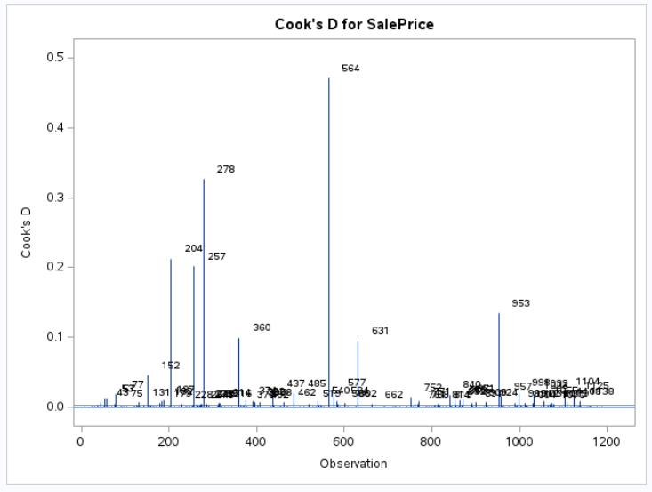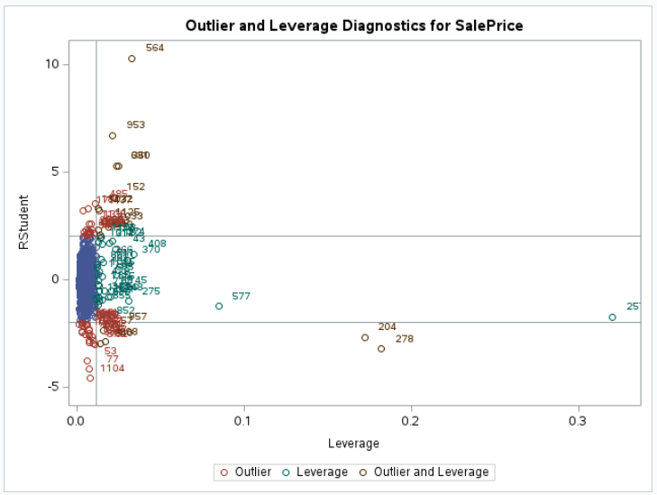

##### After Transformation/Removal:

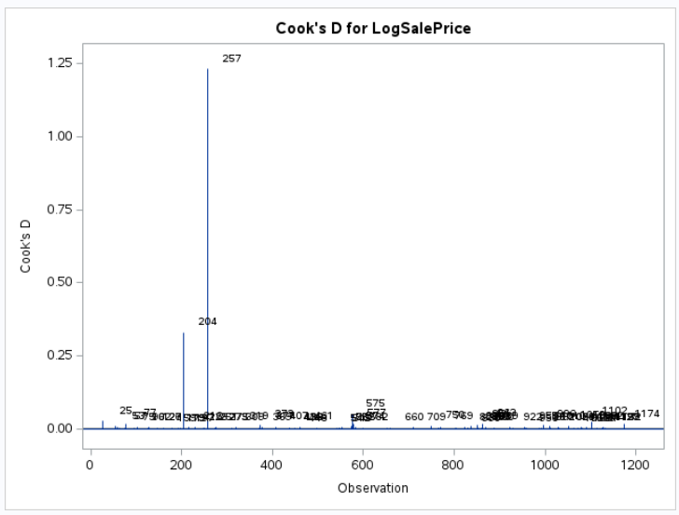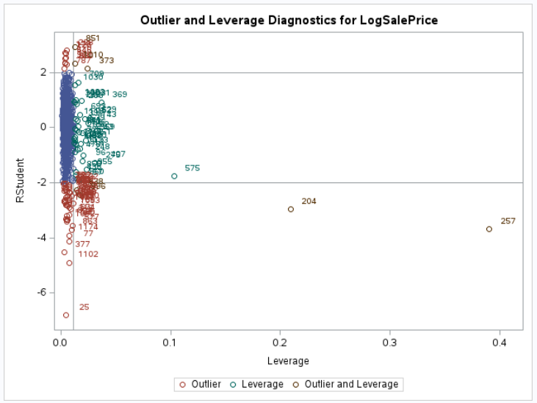

### Kaggle Results

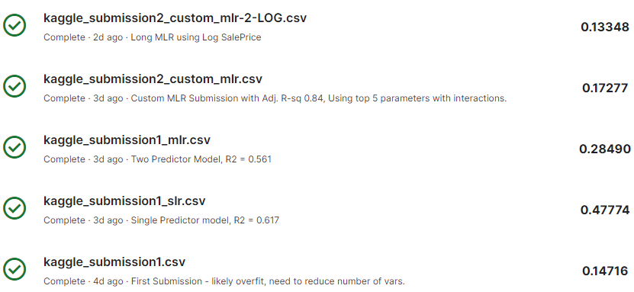

1. <https://www.kaggle.com/c/house-prices-advanced-regression-techniques/overview>
2. <https://github.com/tskunz/MSDS6371_House_Regression_Project/blob/main/house-prices-advanced-regression-techniques/data_description.txt>